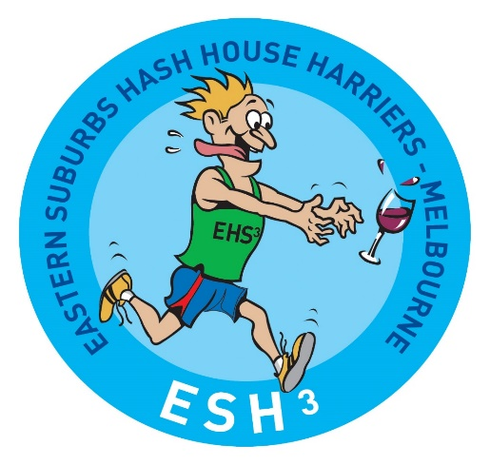

History of the Eastern Suburbs Hash House Harriers
A drinking group with a few runners but more walkers
The Eastern Suburbs hash House Harriers (SH3) was founded in 1977 by Ross Hallam (Spiderman) who had transferred to Melbourne from Darwin where he had some experience with a local Hash group.
The first run, which attracted 8 runners, was held on the 6^{th,} June ,1977, from Highfield Park in East Camberwell and an anniversary run is held each year around this date from the same location.
Those on the first run were the following
Ross Hallam (Spiderman)
John Anstee (Big Ant)
Max Tritton (Reverand)
Ray Johns (Hash Horn)
Ian Thomas (Stud)
Alan Butchaski (Butch
Tim Kelly ( I’ll be back)
Barry Rowe (Saville)
Only Max Tritton (Reverand) is still running today

